Severe Acute Respiratory Syndrome Coronavirus 2 (SARS-CoV-2)

Family: Coronaviridae
Genus: Betacoronavirus

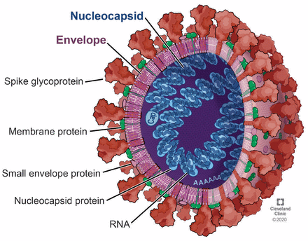

Reason for choice:

- Globally impactful pandemic virus
- Rapid evolution allows analysis of mutations and forecasting of variants
- Well-studied protein-coding genes and functional mutations
- Huge number of genome sequences publicly available

Life Cycle and Biology

- Spike protein on the virus binds to the ACE2 (Angiotensin-Converting Enzyme 2) receptor on human cells
  - ACE2 Receptor: crucial protein on cell surfaces that normally helps regulate blood pressure by breaking down harmful angiotensin II
  - Angiotensin II: powerful peptide hormone and vasopressor central to the Renin-Angiotensin-Aldosterone System (RAAS) that regulates blood pressure, fluid balance, and electrolyte levels by constricting blood vessels, stimulating thirst promoting sodium/water retention.
    - Can contribute to cardiovascular diseases, like hypertension, when overactive
- Replication: ORF1ab polyprotein produces non-structural proteins for replication
- Assembly & Release: Nucleocapsid packages RNA; structural proteins form the virion
- Transmission: Respiratory Droplets, aerosols; high human-to-human transmissibility

Key Genes

Gene | Function | Relevance for variant risk
S gene | Encodes the spike protein, one of the main structural proteins of the virus. It is responsible for viral entry into host cells. The spike protein has three core functions:  Receptor binding  Membrane fusion  Initiating infection | Mutations can alter transmissibility and immune escape
N gene | Encodes the nucleocapsid protein, another structural protein. The protein binds and packages the viral RNA genome. | Mutations may affect replication efficiency or diagnostic detection
ORF1ab | Encodes the viral replication machinery. Produces one giant polyprotein that is cleaved into 16 nonstructural proteins (nsp1-nsp16). It runs the entire replication and transcription process. | Mutations may change replication speed or virulence
Accessory proteins (ORF3a, ORF8, etc) | Modulate host immune response.  ORF3a: encodes a protein involved in host interaction. It modulates ion channel activity, promotes inflammation, and assists viral release from the cell.  ORF8: modulates host immune recognition. Known for interfering with antigen presentation | Mutations may help the virus evade immunity

Notes:
- Spike protein is the primary target of vaccines
- Mutations in receptor-binding domain (RBD) or furin cleavage site are particularly significant
  - Furin cleavage site: A specific amino acid sequence in a protein that is recognized and cut by the protease enzyme furin, essential for activating viral and cellular proteins. This allows viruses to fuse with host cells and enables infection.

Mutations of Interest

Name | Mutation | Gene Location | Effect/Concern
D614G Mutation | Replaces aspartic acid with glycine at position 614. | Spike protein | Increased viral infectivity and transmissibility by making virions more stable and infectious. Led to higher viral loads in upper respiratory tract. This was the dominant form of the virus early in the pandemic
N501Y Mutation | Asparagine replaced with tyrosine at position 501 | RBD | Increases ACE2 binding & increases transmissibility. This was seen in the Alpha, Beta, and Gamma variants
E484K Mutation | Glutamic acid Lysine at position 484 | RBD | Reduces neutralization by antibodies leading to immune escape. Present in Beta, Gamma, and some Delta lineages.
L452R Mutation | Leucine Arginine at position 452 | RBD | Increased transmissibility and causes partial immune escape. Present in Delta variant
P681R Mutation | Proline Arginine at position 681 | Near furin cleavage site | Enhances spike cleavage leading to faster viral entry. This is key in delta variant spread.
T478K Mutation | Threonine Lysine at position 478 | RBD | May enhance binding and immune escape. Present in Delta variant.
R203K Mutation | Arginine Lysine at position 203 | Nucleocapsid | May enhance viral replication. Often paired with G204R
G204R Mutation | Glycine Arginine at position 204 | Nucleocapsid | May enhance viral replication. Often paired with G204R
Exonuclease Mutation | Various mutations at various positions | ORF1ab | Can reduce proofreading and cause a higher mutation rate
Helicase Mutation | Various mutations at various positions | ORF1ab | May alter replication efficiency, however less characterized mutation.
Q57H | Glutamine Histidine at 57 | ORF3a | May affect viral release or host response. Observed in multiple variants.

Why These Mutations Matter
- Spike protein mutations can affect:
  - Vaccine effectiveness
  - Antibody neutralization
  - Transmissibility
- Nucleocapsid mutations can affect:
  - Viral replication efficiency
  - Diagnostic sensitivity
- ORF1ab mutation can affect:
  - Viral replication machinery
  - Potential antiviral drug susceptibility

Genomic Data Availability
- Sources:
  - GISAID: Largest SARS-CoV-2 database, sequences with metadata
  - NCBI GenBank: Public genome repository
  - Nextstrain: Preprocessed phylogenetic datasets and lineage tracking
- Metadata included:
  - Collection date
  - Geographic location
  - Lineage/variant annotation
  - Host information

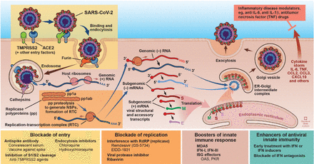
Image Citation

Bergmann, C. C., & Silverman, R. H. (2020). COVID-19: Coronavirus replication, pathogenesis, and therapeutic strategies. Cleveland Clinic Journal of Medicine, 87(6), 321–327. https://doi.org/10.3949/ccjm.87a.20047

